**IOT Based Real-Time Customer Retention Tracking and Comprehensive**

**Analysis using LangChain & LangGraph**

Prof. Sheela Chinchmalatpure, Anurag Raut, Ridham Anand, Rimaz Bhaldar, Rohan Khanna

**Vishwakarma Institute of Technology, Pune, 411037, Maharashtra, India**

[1]

***Abstract*** *—*

Customer loyalty is important for the continued existence of business in general and, particularly for large exhibitions and events, because of the difficulty involved in ensuring the attendees visit all the stands. On the other hand, such traditional methods as research and observation analysis are usually insufficient, prone to errors, and devoid of implementing insights in practice. The project proposes a solution in the form of an IoT-based real-time customer binding system and an advanced analytical oversight based on Langchain and Langgraph for intelligent data processing and decision-making. Such insights are processed in cloud-based analytics so that the companies can analyze engagement metrics and effectively optimize stand layout. Chatbots built with the help of Latchain and Langgraph, equipped with an AI mechanism, allow interesting groups to easily inquire about the data and get implementationable recommendations without requiring in-depth technical knowledge. Built to be scalable and easy to deliver, it complies with industry demands for AI-operated optimization and customer experience.

***Key words:*** Customer Retention, Real-Time Tracking, Nordic BLE 4.0, ESP32, LangChain, LangGraph, Cloud Analytics, AI Chatbot, Wearable Devices, Booth Sensors, Data-Driven Insights, Visitor Engagement, AI-Powered Analysis

# ***Introduction***

Customer loyalty plays an important role in long-lasting success in trade fairs and events in today's competitive business environment. Hence, knowledge about the pattern of engagement of the visitors becomes a part of the optimization process with respect to stand layout, product placement, and marketing strategies. However, traditional techniques, be it manual inquiry, casual investigation, RFID detection, or thermal imaging, rarely accomplish real-time knowledge or reasonable data in general. The project proposes an IoT-based loyalty and analytics system with real-time customer constraints and advanced analytics. The technology monitors visitor interactivity and engagement within stands using an ESP32 microcontroller with a Nordic BLE 4.0 chip integrated to track movement patterns through portable devices and, eventually, commodity stands for seamless data collection and transmission. Such real-time knowledge processing loads on to cloud-based analytics to provide the company with a more in-depth understanding of consumer behavior. Built with Lachain and Langgraph, Ai-Aisileated Chat Bot allows the dynamic query of data and easy access to insights without any specialized technical knowledge. The solution proposed is scalable and efficient, and developed in accordance with the modern-day customer loyalty strategies.

# ***Methodology***

The proposed system to assess and analyze the stand loyalty of visitors utilizes a combination of a portable BLE-technology-based device, a corporate state ESP32 technology-based device, real-time data transmission through websites, and an AI to monitor people. Correspondingly, the portable BLE devices track the movements of the participants and collect and transmit this data in a real-time environment through a stand-installed ESP32 microcontroller. Then, through the use of cloud analytics, the data is further processed to get insights into retention patterns.

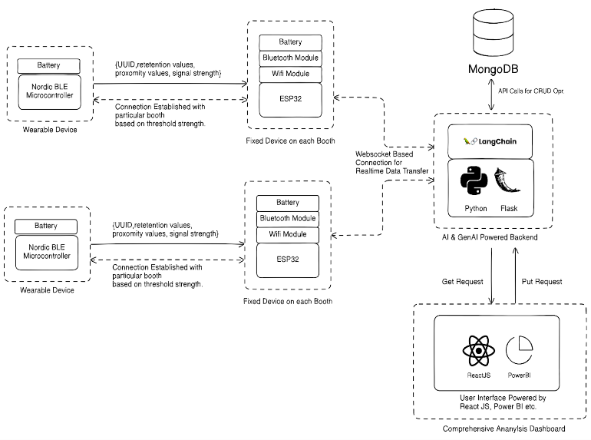

*Fig 1: System Architecture*

**I. System Components and Setup -**

The proposed system encompasses BLE-based portable devices, ESP32-based stationary receivers, web socket-based real-time data transmission, and AI control analysis for monitoring the binding of participants to the exhibition stand. The hardware and software components have the following configuration:

A. *Wearable Devices: Data Collection and Transmission*

Each participant carries a portable BLE device for real-time data collection. The device is based on Nordic BLE 4.0 NRF51822 microcontroller for low power wireless communication, coupled with a battery operation module for operating disquisitions. The BLE radio sends important parameters at predefined intervals like clear UUIDs for identifying the participants, retention time and duration near the booth, proximity values based on RSSI for distance estimations, and signal surges for dynamic adaptations. This portable device continuously emits a BLE packet and, according to the convention, is identified by the receiver after entering a predefined RSSI threshold state.

B. *Booth Based Fixed Device: Data reception and edge processing*

Each exhibition stand is equipped with an ESP32-based receiver that processes and transfers visitor interaction data. The finished product consists of: ESP32 microcontroller for BLE scanning and stand recognition, Bluetooth module for real-time bonding with nearby portable devices, Wi-Fi module ensuring seamless communication with backend, and a dedicated battery unit for separate power supplies for the RSCA supplying the stand. The signal persistence is monitored, change of signal to adaptively fine-tune stopping accuracy, and UUID correlation to identify participants. The collected data is streamed in real time and uploaded to the backend.

**II. Data Processing and AI Control Analysis**

A. *Backend System Architecture*

The backend will be accountable for understanding data capture, storage, and AI control. The data processing pipeline depends on an interface-based interface continuously getting data from an ESP32-based stand device. API-based API endpoints handle database interactions and data calls, while structured data records such as staff support protocols, aggregate proximity trends, and statistics on commitment periods are stored in the MongoDB systems.

B. *AI analysis using LangChain & LangGraph*

There is a machine-learning and natural language approach responsible for designing ways to extract wise knowledge. A pattern recognition algorithm recognizes high and low commitment zones across the stand. The model for recognizing abnormalities focuses on abnormal trends in one's retention. Will chatbots made with Langchain and Langgraph allow any NLP chatbots to interactively challenge questions about levels and other things to maximize visitors?"

**III. Data Visualization and Knowledge Generation**

A. *Real-Time Analytics Dashboard*

The system essentially is a Reactjs-based web monitoring and analysis interface where the dashboard offers onboarding integration for an interactive and dynamic data visualization, a retention thermal mapper to know the trend for participant movements, and an AI conversation interface for an intuitive and funny analysis.

B. *Business Impact Assessment*

Dashboards powered decision-making. With data visualization, interest groups can and should identify high-ranking staff who are candidates for future resource allocation, Areas of less engagement could be improved strategically; the flow of visitor movement updates would enlighten and improve designs for the booths.

**IV. System Deployment Strategy**

Designed to allow modular provisioning, the system supports scalable hardware integration, with various stands able to work independently of each other. Cloud-based memory ensures real-time access with customizable AI models that are adaptable for different event scenarios.

# ***Literature Review***

Customer loyalty was examined in detail in marketing, HR and business analysis. The AI control predictive analysis and commitment strategies for RFV retention have been studied for many years, among them Madanchian (2024), who discusses AI tools for decision-making in HR and Kemparaju et al. (2023) investigating applications for machine learning for employee loyalty. Basnet (2020) examines the role played by AI in predictive analytics for customer loyalty. Ascarza et al. (2019) address data-controlled retention management analysis, while Letting (2018) exhibits CRM practices. The study expands on all of the above by building on them with IoT-based real-time tracking and AI analytics as an improvement in customer loyalty. Using Langchain and Langgraph, dynamic data processing and interactive query technology allows traditional retention analytics to handle gaps.

# ***Future Scope***

The proposed system also has a significant improvement and expansion potential. Future developments would need to see deep-learning AI models for more precise storage predictions. The system can be adapted for retail, hospitality, healthcare, and many other applications that enhance customer loyalty. Integration of Blockchain ensures secure data collection and data that is impossible to manipulate. Edge computing allows latency to be decreased by processing the data on-site with greater detail. Further additional explicit biometrics or surrounding sensors can capture slight nuances of customer behavior. Automated triggers for actions enable an immediate adjustment in stand layouts and marketing strategies based on real-time analysis which, in turn, enables fast adaptability of your system.

# ***Conclusion***

The project presented here develops a BLE-based real-time customer-binding tracking system integrated with AI-processed insights. The combination of portable BLE devices that are recipients of ESP32 on booth-based AI allows businesses to monitor visitor commitments at exhibitions and large events. Actual tracking and analysis provide a data control approach to optimize visitor experience and improve retention. The modular architecture ensures scalability and enables seamless integration across different industries. Future improvements such as deep learning for more precise behavioral analysis and expansion to other areas like retail and hospitality could further increase applicability. Incorporating better AI models and using blockchains could enhance the precision and reliability of the system for safe data processing. By overcoming current limitations present in traditional retention analytics, the solution will pave the way for a more efficient AI-controlled customer commitment and engagement.

***V. ACKNOWLEDGMENT***

We express our gratitude to Professor Sheela Chinchmalatpure for her valuable guidance and insights throughout the project. We would also like to thank our colleagues and faculty at the Vishwakarma Institute of Technology, Pune, for their guidance and constructive feedback. Special thanks go to the developers of Langchain and Langgraph, as this enabled the implementation of the AI control analysis systems.

***VI. References***

1. Mitra Madanchian, “From Recruitment to Retention: AI Tools for Human Resource Decision-Making (2024)” - Applied Sciences.
2. Prof. Kemparaju N, Ms. Latha JA, Ms. Likitha M B, Ms. Prerana Hiremath, Ms. Vaishnavi Ram J “Employee Retention Analysis Using Machine Learning (2023)” - International Journal for Research in Engineering Application & Management (IJREAM).
3. Sunil Basnet, “The Impact of AI-Driven Predictive Analytics on Employee Retention Strategies” - International Journal of Trend in Scientific Research and Development (2020).
4. Eva Ascarza, Scott A. Neslin, Oded Netzer, Zachery Anderson, Peter S. Fader, Sunil Gupta, Bruce Hardie, Aurélie Lemmens, “In Pursuit of Enhanced Customer Retention Management (2019)” - Journal of Service Research.
5. A. Letting, “The Effect of customer relationship management practices on customer retention in the exhibition industry within Nairobi City County (2018)” - International Journal of Scientific and Research Publications.
6. Bhenu Artha, Inna Zahara, Bahri, Niken Permata Sari, "Customer Retention: A Literature Review (2014)" - Journal of Business & Economics Research.
7. “Supporting Customer Retention through Real-Time Monitoring of Customer Complaints (2017)" - International Journal of Operations & Production Management.
8. Neeraj Kripalani, "Predictive Analytics for Customer Retention: A Data-Driven Framework for Proactive Engagement and Satisfaction Management (2021)" - Journal of Marketing Analytics.

1.